**- CC Practical 1A –**

**Aim**: Define a Simple SOAP Service like Converting Rs into Dollars and Call it from different Platforms. **STEPS:** 1) Open Netbeans.

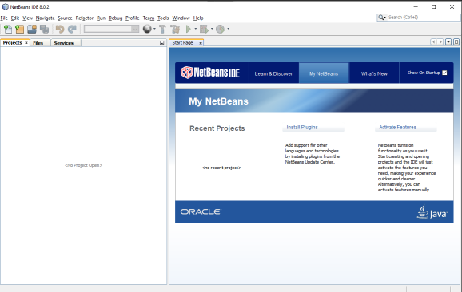

2) Create New Project. Select ‘Java Web’ from Categories & ‘Web Application’ from Projects. Click Next.

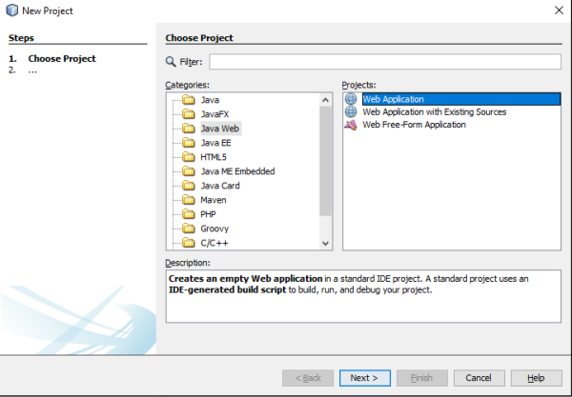

**- CC Practical 1A –**

3) Name your Project and choose Location then Click Next, Ensure Glassfish Server is Selected then Click Finish.

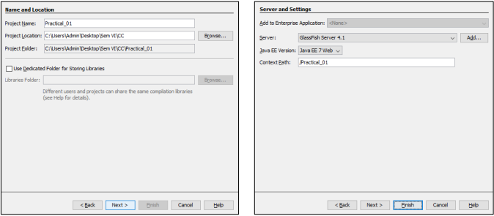

4) Expand your project by clicking on ‘+’ symbol, Select: New → Web Service.

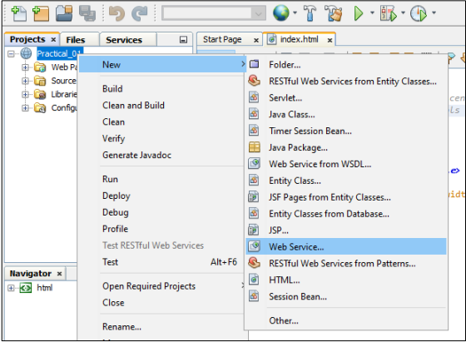

**- CC Practical 1A –**

5) Name your Service and type ‘server’

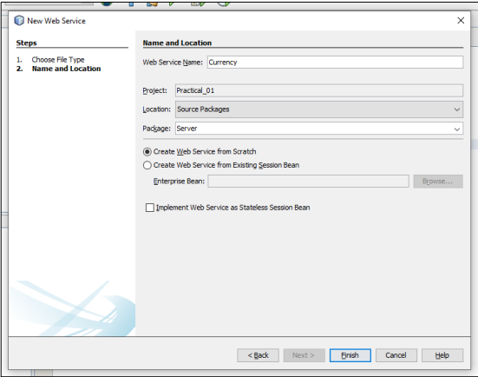

6) Erase Sample Code and Right-Click anywhere inside the code. Insert Code and select Add Web Service Operation within.

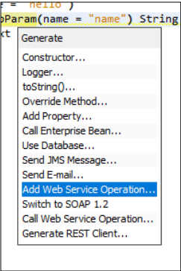

**- CC Practical 1A –**

7) In the dialog Box, Name your Method/Operation & Add a parameter. Name it and select its type.

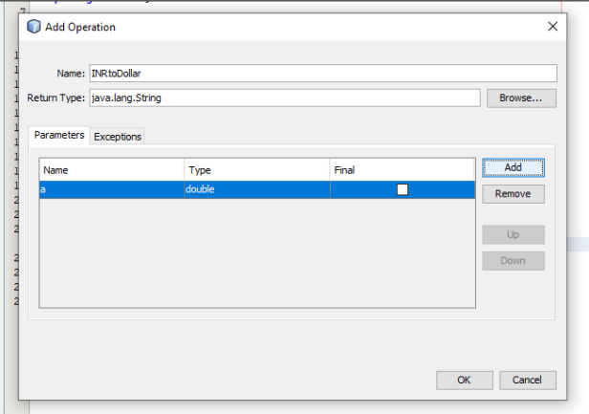

8) In the auto-generated Code, do the following Changes.

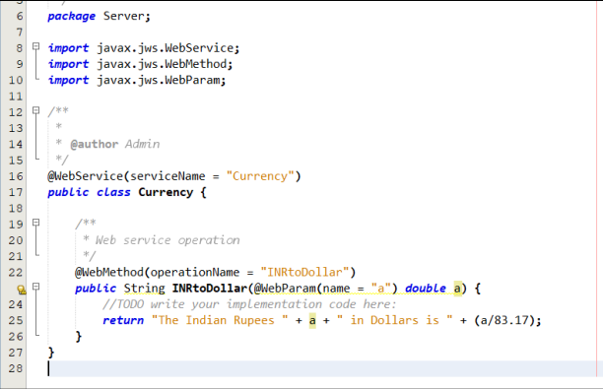

**- CC Practical 1A –**

9) Deploy Project.

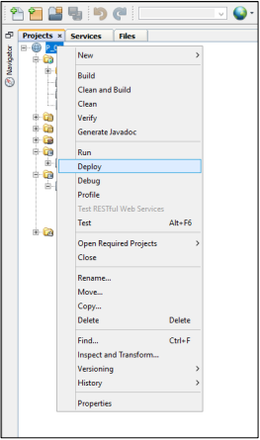

10) Click on your Web Service and Test it.

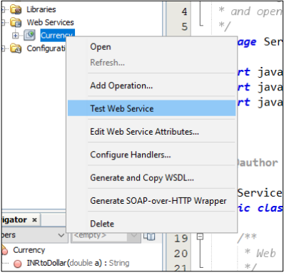

**- CC Practical 1A –**

Output prompting Input to Convert Currency (INR to Dollar).

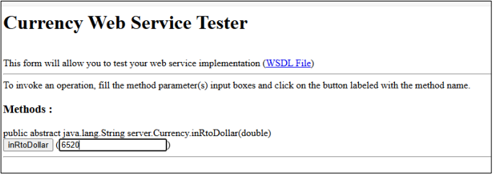

**Final Output**

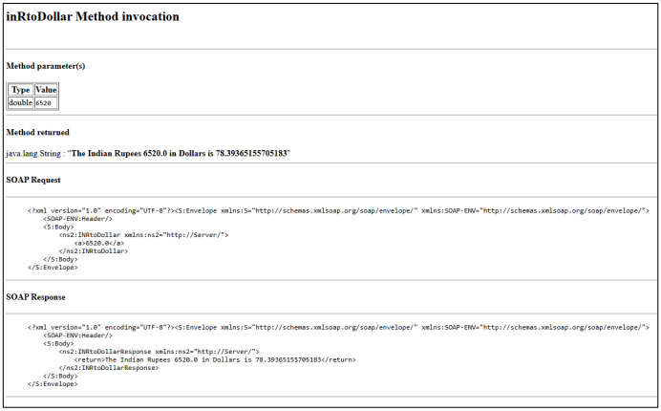

**- CC Practical 1B –**

**Aim:** Creating JSP Client

**STEPS:**

Step 1: Create JSP (Java Server Page).

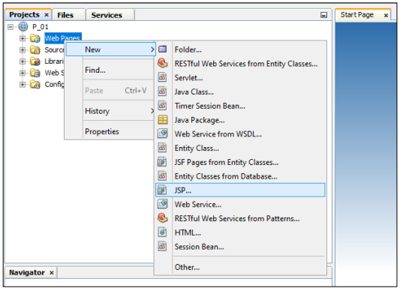

Step 2: Enter File Name and Click on Finish.

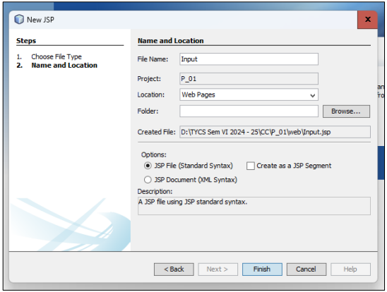

**- CC Practical 1B –**

Step 3: Write following Code in “Input” File.

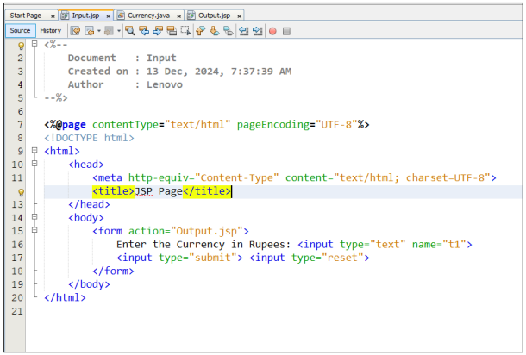

Step 4: Create Web Service Client for the Project.

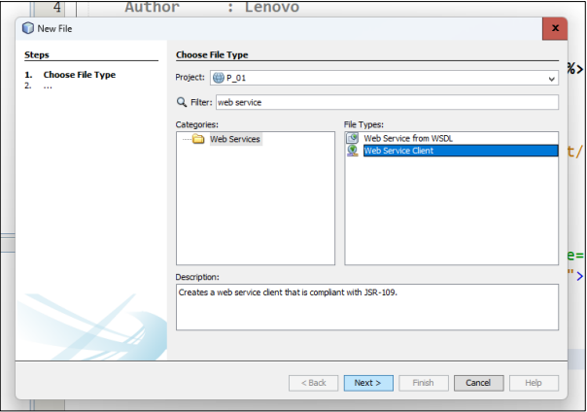

**- CC Practical 1B –**

Step 5: Specify Project URL and Type Package as “Client”..

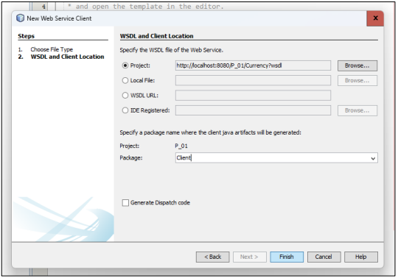

Step 6: Create second JSP, name it as Output and Write the following Code.

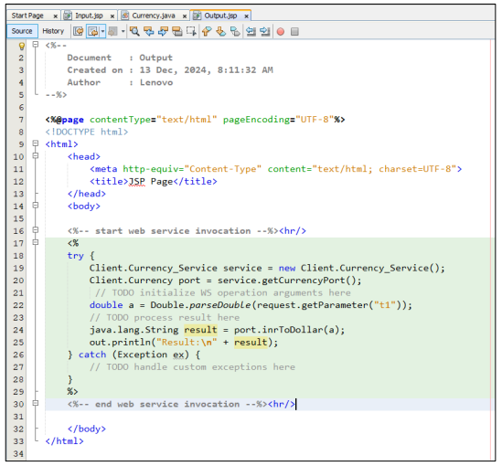

**- CC Practical 1B –**

Step 7: Deploy Project and Run the “Input” file.

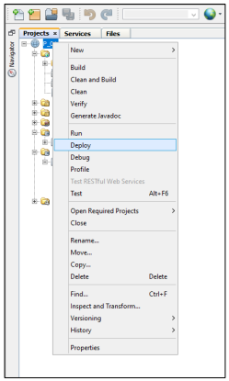

Output prompting Input to Convert Currency (INR to Dollar).

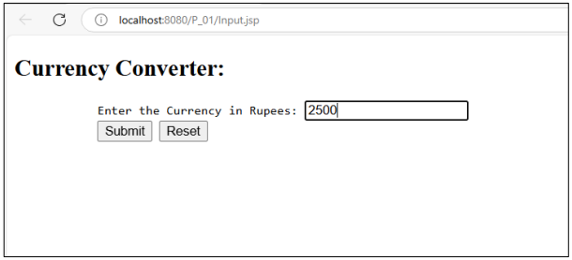

**Final Output**

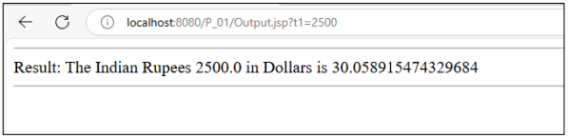

**- CC Practical 2A –**

**Aim:** Define a Simple SOAP Service like Temperature Conversion and Call it from different Platforms. **STEPS:** Step 1: Create New Project and then Create Web Service to Convert Temperature (F to C). Step 2: In the auto-generated Code after creating Web Service, do the following Changes.

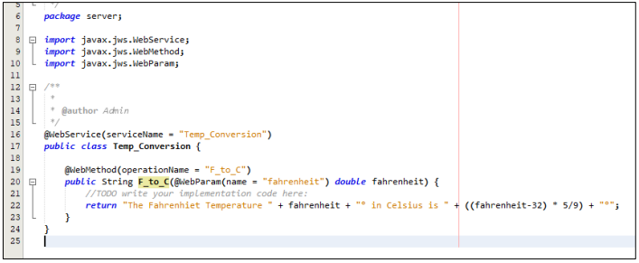

Step 3: Deploy Project and Test Web Service.

Output prompting Input to Convert Temperature (F to C).

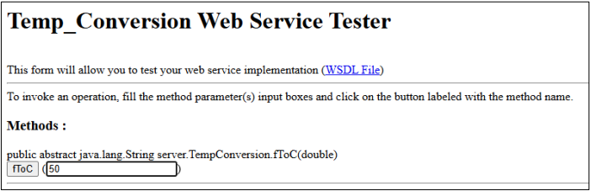

**Final Output**

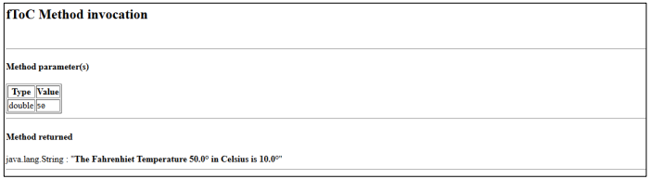

**- CC Practical 2B –**

**Aim:** Creating JSP Client **STEPS:** Step 1: Create JSP (Jakarta Server Page). Step 2: Write following Code in “Input” File.

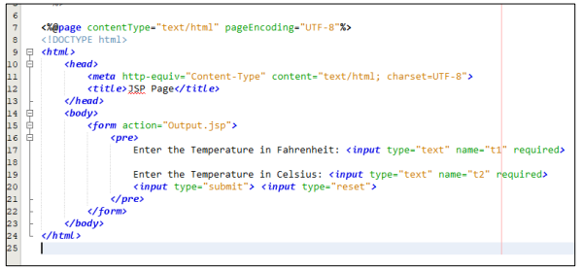

Step 3: Create Web Service Client for the Project. Specify Project URL and Type Package as “Client”. Step 4: Create second JSP, name it as Output and Drag the Operation from Web Service **References →** **Temp_Conversion → Temp_ConversionPort → F_to_C** into body tag.

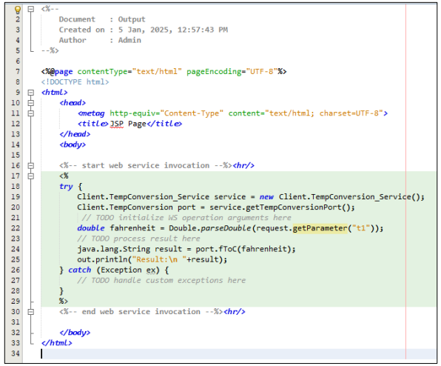

**- CC Practical 2B –**

Step 5: Deploy Project and Run the “Input” file.

Output prompting Input to Convert Temperature (F to C).

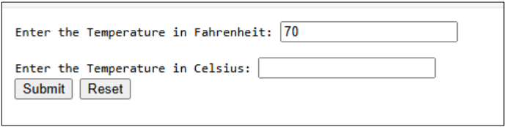

**Final Output**

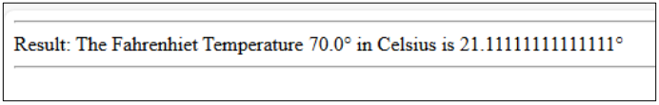

**- CC Practical 04 –**

**Aim:** Develop application to consume Google’s search / Google’s Map Restful Web service. **STEPS:** Step 1: Create a Java Web application and create two jsp pages- input.jsp and index.jsp

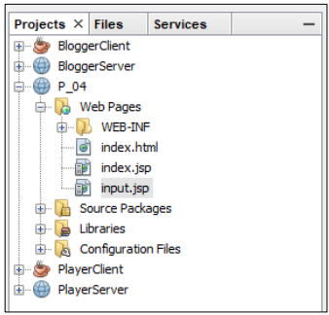

Step 2: Write down below code in input.jsp file.

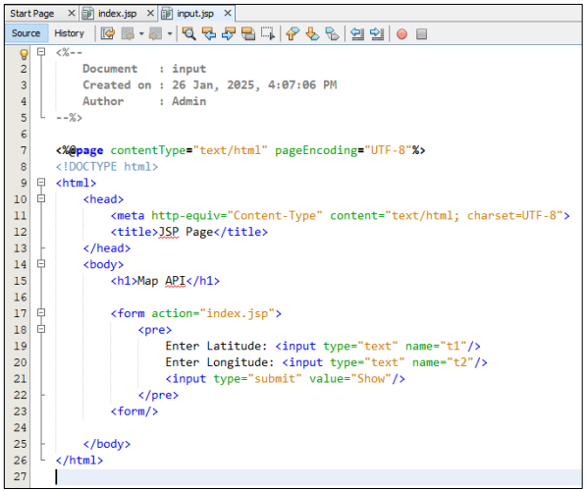

**- CC Practical 04 –**

Step 3: Before running the application, we need the Google API key. The steps are shown here: **Visit Google APIs Console (https://console.developers.google.com, you have to login with your Google account)**

Step 4: Now create a project as shown below.

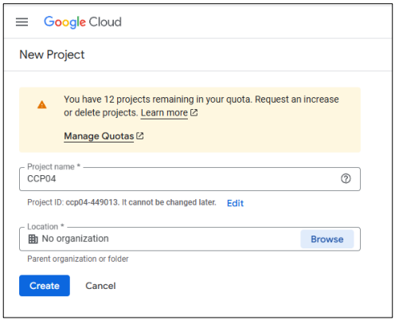

Step 5: After creating the project successfully, it will redirect you to below screen. Now you have to enable Maps Javascript API. Click on Enable APIS & Services → Search for maps javascript api → Enable it.

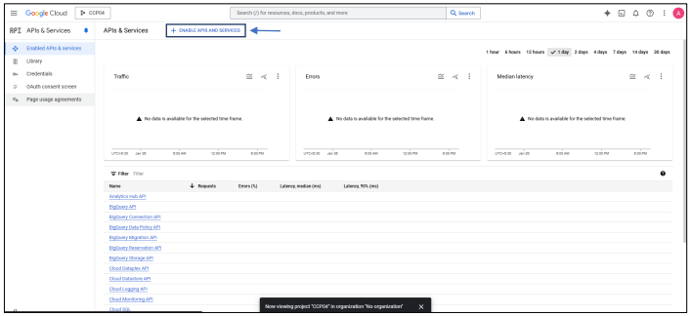

**- CC Practical 04 –**

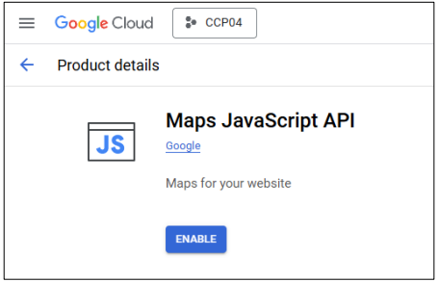

Step 6: Agree & Continue in Account Info Step. Next Leave verify your Identity Step and navigate to Credentials Tab on Left Side. Click on Create Credentials and then Click on API Key.

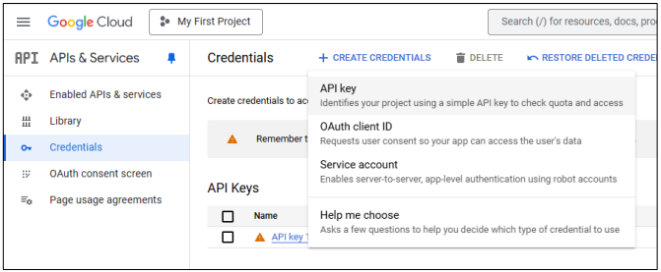

Step 7: Edit your API Key

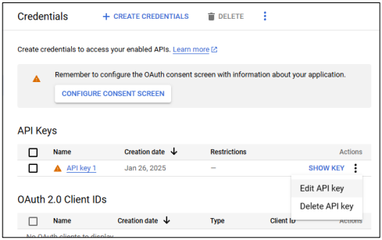

**- CC Practical 04 –**

Step 8: Now, Select **Websites** in App Restrictions Category, Select **Restrict Key** in API Restrictions and Checkmark **Maps Javascript API** in Options. Save it.

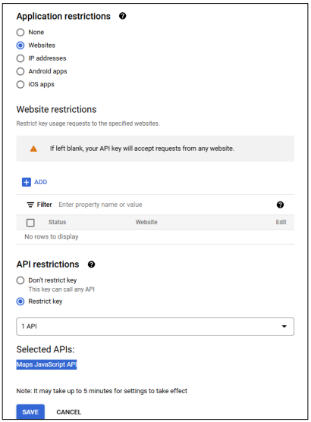

Step 9: View your Key.

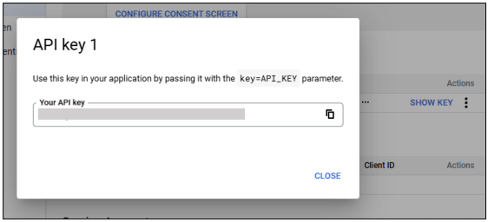

**- CC Practical 04 –**

Step 10: Implement full Code in index.jsp (Paste **your API Key** in Code)

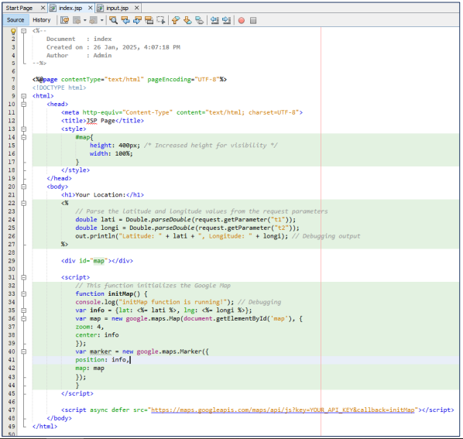

Step 11: Now Deploy the Project and Run Input.jsp **OUTPUT:** Latitude and Longitude Prompt:

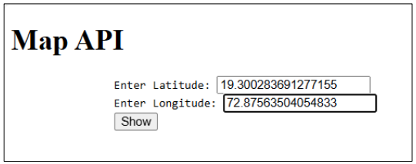

Final Output: 